BansilalRamnathAgarwalCharitableTrust’s

VishwakarmaInstituteofTechnology, Pune-37
(AnautonomousInstituteofSavitribaiPhulePuneUniversity)


Department of Multidisciplinary Engineering

Division | AIML-A
Batch | B2
GR-no | 12414334
Rollno | 49
Name | Bhagat Rishikesh Vijay

Assignment No. 9
Title - KMeans
- Theory
K-Means Clustering in Machine Learning
1. Introduction to K-Means Clustering
K-Means Clustering is an unsupervised machine learning algorithm used to divide a dataset into K distinct groups called clusters. It groups data points based on their similarities, typically measured using distance.
The algorithm works without predefined class labels and attempts to place similar data points in the same cluster.
The term K-Means consists of three components:
- K: The number of clusters to be created.
- Means: The average position of the data points in a cluster, which determines its centroid.
- Clustering: The process of grouping similar data points together.
Example: A shopping mall can use K-Means to segment customers into three groups based on annual income and spending habits. These groups may represent low, medium, and high spending patterns, depending on the data.
2. Working of K-Means Clustering
K-Means follows an iterative process to form clusters.
- Choose K: Decide the number of clusters to create, such as (K=3).
- Initialize centroids: Select initial centroid positions for the clusters.
- Assign data points: Assign each data point to the nearest centroid, commonly using Euclidean distance.
- Update centroids: Calculate the mean of the data points assigned to each cluster and update the centroid positions.
- Repeat the process: Continue assigning points and updating centroids until the assignments stop changing, the centroids converge, or the maximum number of iterations is reached.
The algorithm aims to create clusters in which data points are as close as possible to their respective centroids.
3. Important Formulas in K-Means Clustering
A. Euclidean Distance
Euclidean distance measures the straight-line distance between a data point and a cluster centroid.
For two-dimensional data, the formula is:
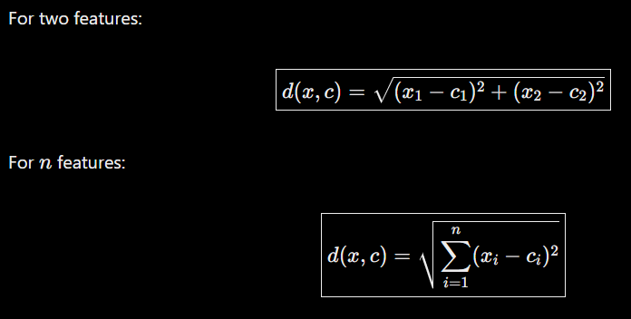
Where:
- (x_1,x_2) represent the features of the data point.
- (c_1,c_2) represent the coordinates of the centroid.
- (d(x,c)) represents the distance between the data point and the centroid.
K-Means generally assigns each data point to the cluster whose centroid has the smallest distance from that point.
B. Centroid Calculation
A centroid represents the mean position of all data points assigned to a particular cluster.
For cluster (j), the centroid is calculated as:
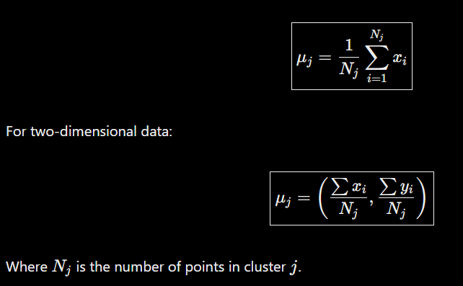
Where:
- (C_j) represents the centroid of cluster (j).
- (n_j) is the number of data points in that cluster.
- (x_i) represents a data point assigned to the cluster.
The centroid is updated whenever the data points are reassigned during an iteration.
C. Within-Cluster Sum of Squares (WCSS)
WCSS measures the total squared distance between data points and their assigned cluster centroids.
The objective function is:
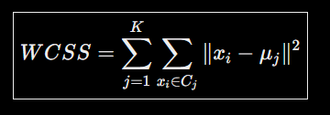
Where:
- (K) is the number of clusters.
- (C_j) represents cluster (j).
- (x_i) is a data point in that cluster.
- (\mu_j) is the centroid of cluster (j).
K-Means attempts to minimize WCSS, producing clusters in which data points are close to their respective centroids.
4. Advantages and Disadvantages of K-Means Clustering
Advantages
- Simple to implement: The algorithm is easy to understand and apply.
- Computationally efficient: It can process many datasets efficiently, particularly when the number of clusters and features is moderate.
- Effective for compact clusters: It works well when clusters are relatively compact and well separated.
- Useful for exploratory analysis: It helps discover patterns and groupings in unlabeled data.
- Scalable: It can handle large datasets with suitable implementations and parameter settings.
Disadvantages
- Requires choosing K: The number of clusters must be specified before fitting the model.
- Sensitive to outliers: Extreme values can affect centroid positions and cluster assignments.
- Initialization dependence: Different initial centroid positions may produce different results.
- Limited with irregular shapes: It may perform poorly when clusters have complex shapes or substantially different densities.
- Feature scaling sensitivity: Features with larger numerical ranges can dominate distance calculations.
- May converge to a local optimum: The algorithm does not guarantee finding the globally optimal clustering solution.
5. Applications of K-Means Clustering
K-Means is widely used in different fields to identify patterns and group similar data points.
- Customer Segmentation: Groups customers according to purchasing behavior, income, and spending patterns.
- Document Clustering: Groups news articles and documents based on their numerical feature representations.
- Image Compression: Reduces the number of colors used in an image by grouping similar color values.
- Shopping Behavior Analysis: Identifies groups of customers with similar shopping habits.
- Product Grouping: Organizes products according to similarities in their characteristics.
- User Profile Analysis: Groups users based on their preferences and activity patterns.
- Exploratory Data Analysis: Helps discover hidden groupings in datasets without predefined labels.
6. Conclusion
K-Means Clustering is a widely used unsupervised machine learning algorithm that divides data into K clusters based on similarity. It repeatedly assigns data points to their nearest centroids and updates the centroids until the algorithm converges or reaches its stopping condition.
The algorithm aims to minimize the Within-Cluster Sum of Squares (WCSS), making it useful for customer segmentation, image compression, document clustering, and pattern discovery. Although it is simple and efficient, its performance depends on selecting an appropriate number of clusters, initializing centroids, and preparing the data properly. Feature scaling and suitable selection of K can help improve clustering results.

